Divide and Conquer – Sorting Algorithms
Merge Sort and Quick Sort performance comparison
Dr. P.SRIRAMYA
V TEJA SREE (192411211)
1. Merge Sort with Comparison Count
Implement the Merge Sort algorithm to sort a given array of integers. The program should recursively divide the array into smaller subarrays and then merge them in a sorted manner. While merging, count the number of element comparisons performed. Ensure that the comparison counter is incremented at every comparison step. Finally, print the sorted array along with the total number of comparisons made during execution.
Test Cases :
Input : N = 8, a[] = {12,4,78,23,45,67,89,1}
Output : 1,4,12,23,45,67,78,89
Comparisons : 17
Input : N = 6, a[] = {5,2,9,1,6,3}
Output : 1,2,3,5,6,9
Comparisons : 11
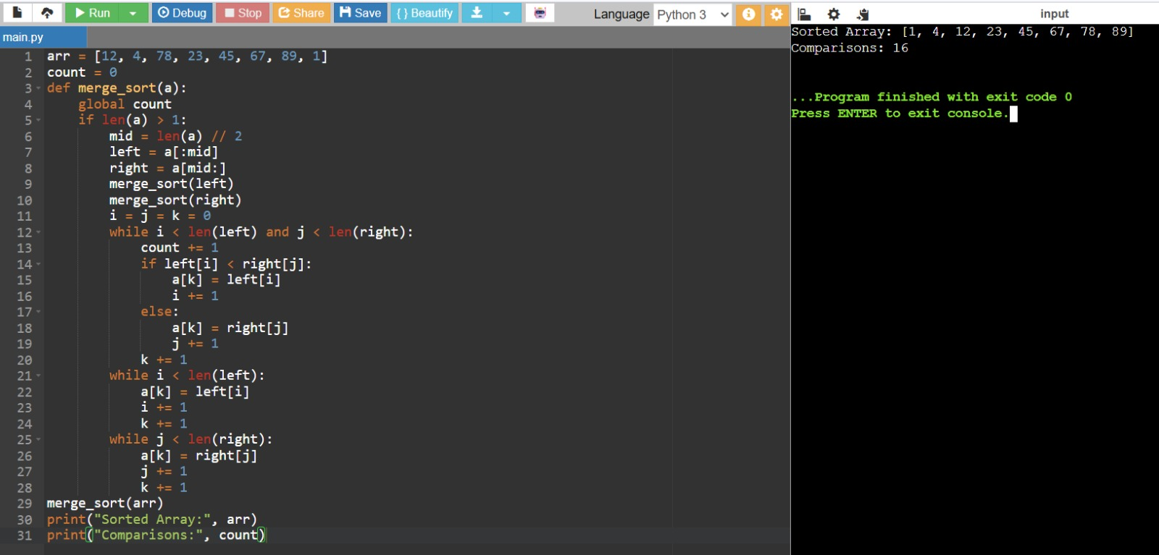
2. Quick Sort with Comparison Count
Write a program to implement the Quick Sort algorithm using the last element as the pivot. The program should partition the array based on the pivot and recursively sort the subarrays. Count the number of comparisons made during the partitioning process and recursive calls. Ensure that the count is accurate for all cases. Display the sorted array along with the total number of comparisons.
Test Cases :
Input : N = 7, a[] = {38,27,43,3,9,82,10}
Output : 3,9,10,27,38,43,82
Comparisons : 15
Input : N = 5, a[] = {10,7,8,9,1}
Output : 1,7,8,9,10
Comparisons : 10

3. Merge Sort vs Quick Sort Comparison
Develop a program that implements both Merge Sort and Quick Sort in a single program. The same input array should be used for both algorithms to ensure fairness in comparison. Count the number of comparisons separately for each algorithm. After sorting, display the sorted array
along with the comparison counts of both methods. Analyze which algorithm performs better for the given input.
Test Cases :
Input : N = 6, a[] = {12,11,13,5,6,7}
Output : Sorted Array : 5,6,7,11,12,13
Merge Comparisons : 11
Quick Comparisons : 12
Input : N = 5, a[] = {4,2,6,1,3}
Output : Sorted Array : 1,2,3,4,6
Merge Comparisons : 8
Quick Comparisons : 9

4. Merge Sort Execution Time Measurement
Write a program to measure the execution time of the Merge Sort algorithm. Use appropriate timing functions to record the start and end time of execution. Apply the algorithm on different types of inputs such as sorted and reverse sorted arrays. Display the sorted output along with the time taken for execution. Analyze how input order affects performance.
Test Cases :
Input : N = 7, a[] = {9,8,7,6,5,4,3}
Output : 3,4,5,6,7,8,9
Time Taken : ~0.00002 sec
Input : N = 6, a[] = {1,2,3,4,5,6}
Output : 1,2,3,4,5,6
Time Taken : ~0.00002 sec

5. Best and Worst Case Analysis of Quick Sort
Create a program to analyze the best and worst-case scenarios of Quick Sort. Use a sorted array as the best case and a reverse sorted array as the worst case. Count the number of comparisons for both cases. Display the sorted output along with comparison counts. Compare the efficiency between the two cases.
Test Cases :
Best case
Input : N = 5, a[] = {1,2,3,4,5}
Output : 1,2,3,4,5
Comparisons : 6
Worst Case
Input : N = 5, a[] = {5,4,3,2,1}
Output : 1,2,3,4,5
Comparisons : 10

6. Hybrid Merge Sort with Insertion Sort
Modify the Merge Sort algorithm such that it switches to Insertion Sort when the subarray size becomes small. Define a threshold value to determine when to switch. This hybrid approach should improve performance for small inputs. Print the sorted array after execution. Compare results with standard Merge Sort.
Test Cases :
Input : N = 8, a[] = {12,11,13,5,6,7,3,2}
Output : 2,3,5,6,7,11,12,13
Input : N = 6, a[] = {9,4,6,2,8,1}
Output : 1,2,4,6,8,9

7. Counting Inversions using Merge Sort
Develop a program to count the number of inversions in an array using Merge Sort. An inversion is defined as a pair (i, j) such that i < j and a[i] > a[j]. Modify the merge step to count such inversions efficiently. Print both the sorted array and the inversion count. This helps measure how far the array is from being sorted.
Test Cases :
Input : N = 5, a[] = {2,4,1,3,5}
Output : Sorted : 1,2,3,4,5
Inversions : 3
Input : N = 4, a[] = {4,3,2,1}
Output : Sorted : 1,2,3,4
Inversions : 6

8. Quick Sort Recursion Depth Analysis
Implement Quick Sort and track the recursion depth during execution. Maintain a variable to store the maximum depth reached. Print the sorted array along with the maximum recursion depth. This helps analyze space complexity. Compare depth for different inputs.
Test Cases :
Input : N = 6, a[] = {10,7,8,9,1,5}
Output : 1,5,7,8,9,10
Max Depth : 4
Input : N = 5, a[] = {1,2,3,4,5}
Output : 1,2,3,4,5
Max Depth : 5

9. External Merge Process Simulation
Write a program to simulate the merge step of external sorting. Given two already sorted arrays, merge them into a single sorted array. Do not use built-in sorting functions. Print the final merged output. This represents the core step of Merge Sort.
Test Cases :
Input : a[] = {1,3,5}, b[] = {2,4,6}
Output : 1,2,3,4,5,6
Input : a[] = {10,20}, b[] = {5,15,25}
Output : 5,10,15,20,25

10. Space Complexity Comparison (Merge vs Quick Sort)
Develop a program to compare auxiliary space usage of Merge Sort and Quick Sort. Track extra memory used during execution. Print sorted output along with space usage. Analyze which algorithm is more space-efficient. Use same input for both methods.
Test Cases :
Input : N = 5, a[] = {5,3,8,4,2}
Output : Sorted : 2,3,4,5,8
Merge Space : ~160 bytes
Quick Space : ~80 bytes
Input : N = 6, a[] = {9,7,5,3,1,2}
Output : Sorted : 1,2,3,5,7,9
Merge Space : ~192 bytes
Quick Space : ~96 bytes


11. K-th Smallest Element using Quick Sort Partition
Implement a program to find the k-th smallest element using Quick Sort partition logic. Use partitioning to avoid full sorting. Recursively process only required part. Print the k-th smallest element. This improves efficiency compared to full sorting.
Test Cases :
Input : N = 6, a[] = {7,10,4,3,20,15}, k = 3
Output : 7
Input : N = 5, a[] = {12,3,5,7,19}, k = 2
Output : 5

12. Performance Data Collection for Graph Plotting
Write a program to collect comparison counts of Merge Sort and Quick Sort for different input sizes. Use multiple test arrays and record comparisons. Print results in a structured format. This data can be used for plotting performance graphs. Analyze growth trends.
Test Cases :
Input : N = 5, a[] = {5,4,3,2,1}
Output :
Merge Comparisons : 7
Quick Comparisons : 10
Input : N = 8, a[] = {8,7,6,5,4,3,2,1}
Output :
Merge Comparisons : 17
Quick Comparisons : 28


